 **PANIMALAR ENGINEERING COLLEGE**

**Chennai – 600 123**

**Department of Computer Science & Engineering**

**CS 8811 - Project Work (2022-23)**

**FIRST REVIEW FORM**

**TILE OF THE PROJECT**

**AUTOMATED DETECTION OF ALZHEIMER DISEASE USING CNN ALGORITHM**

**MODULE DESIGN SPECIFICATION**

The model for real-time image detection using CNN in Python involves several key steps:

* **Data collection and acquisition**
* **Data pre-processing**
* **Feature extraction**
* **Classification model**
* **Model evaluation**
* **Model deployment**
* **Data collection and acquisition:**

The dataset used for training the CNN model should be representative of the image that need to be detected. The dataset can be collected from various sources, such as public datasets or custom data collection efforts. Data used in the preparation of this report were obtained from the publicly available Alzheimer’s Disease Neuroimaging Initiative (ADNI) database and the Open Access Series of Imaging Studies (OASIS) project database. The most recent visit in which a diagnosis was made was considered the best available “ground-truth” to train the classifiers.

* **Data pre-processing:**

This step involves pre-processing of the MRI images such as skull stripping, intensity normalization, and image registration. It is important to ensure that the images are of the same size, orientation, and spatial resolution to facilitate easy comparison and analysis.

* **Feature extraction:**

This step involves extracting features from the pre-processed images, such as gray matter volume, cortical thickness, and hippocampal shape. These features are then used to classify the images into Alzheimer's disease (AD) like Mild Demented, Moderate Demented, Non Demented and Very Mild Demented.

* **Classification model:**

The extracted features are then used to train a classification model, as convolutional neural network (CNN), to classify the images as Mild Demented, Moderate Demented, Non Demented and Very Mild Demented.

* **Model evaluation**:

The trained model is evaluated using various metrics such as accuracy, sensitivity, specificity, and F1 score. The evaluation process helps to determine the effectiveness of the classification model and identify areas for improvement.

* **Model deployment:**

The final step involves deploying the classification model to classify new MRI images into Mild Demented, Moderate Demented, Non Demented and Very Mild Demented. The model can be deployed as a standalone application, integrated into existing healthcare systems, or used as a diagnostic tool by healthcare professionals

**SYSTEM ARCHITECTURE**

Pre

-

Processing

splitting

Samples

Training

Dataset

Training CNN

Classifier

Trained

CNN

Test dataset

Validation

Dataset

CNN Classifier

Validation

Prediction

Evaluation

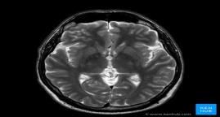

**ALGORITHMS**

* + **CONVOLUTIONAL NEURAL NETWORK**

**DATA FLOW DIAGRAM**

LEVEL 0

Training &

Validation

Dataset

Collection

Fig: Level 0 of Data Flow Diagram

LEVEL 1

Non_demented

Moderate_demented

Mild_Demented

Fig: Level 1 of Data Flow Diagram

LEVEL 2

Model Prediction

Predicted output

Fig: Level 2 of Data Flow Diagram

**USE CASE DIAGRAM**

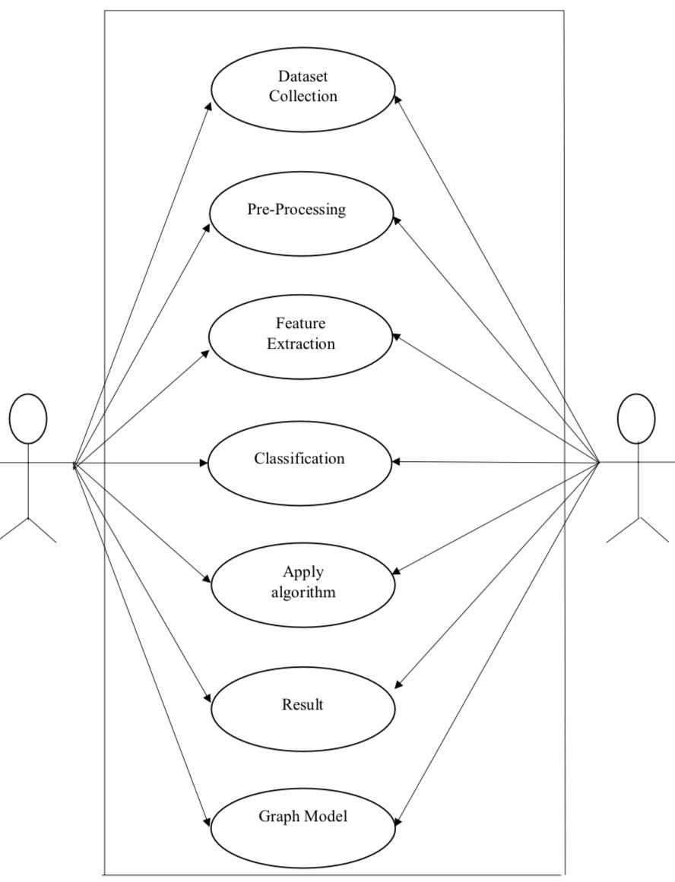

**CLASS DIAGRAM**

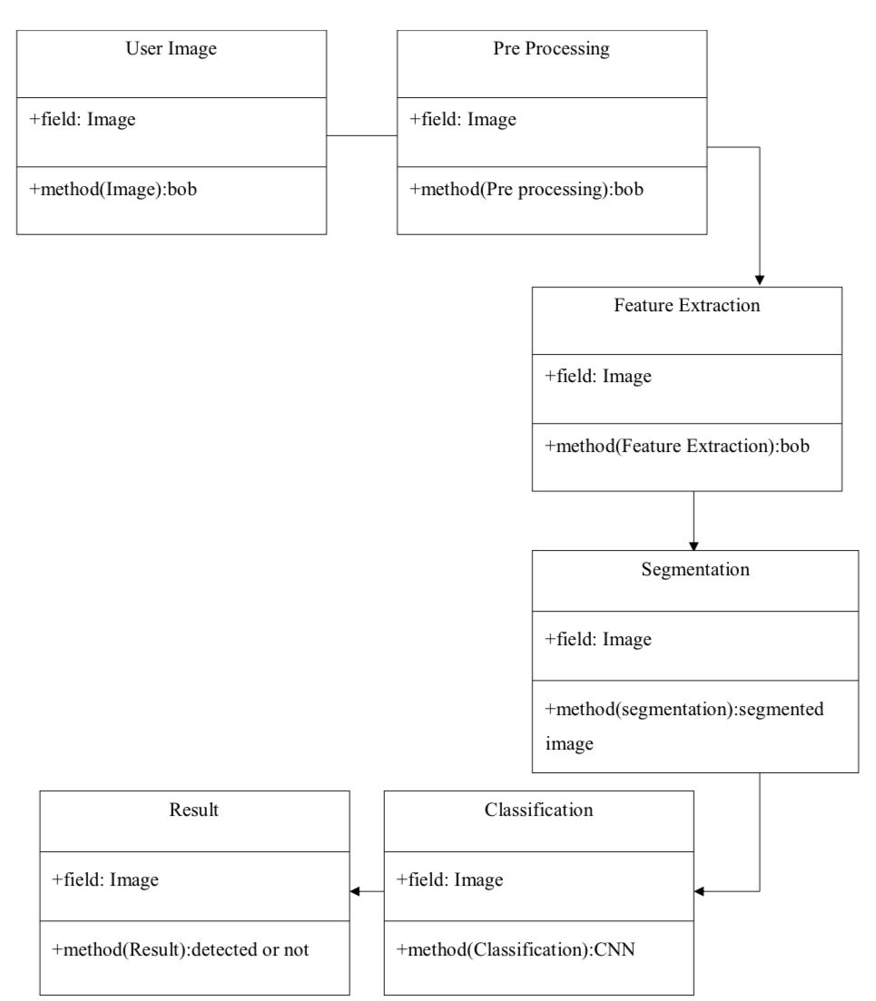

**SEQUENCE DIAGRAM**

**Start**

**Model Pridiction**

**Training**

**Preprocessing**

**Dataset collection**

**Feature Extraction**

**Mild**

**Moderate**

**Very_Mild**

**Non_demented**

**ACTIVITY DIAGRAM**

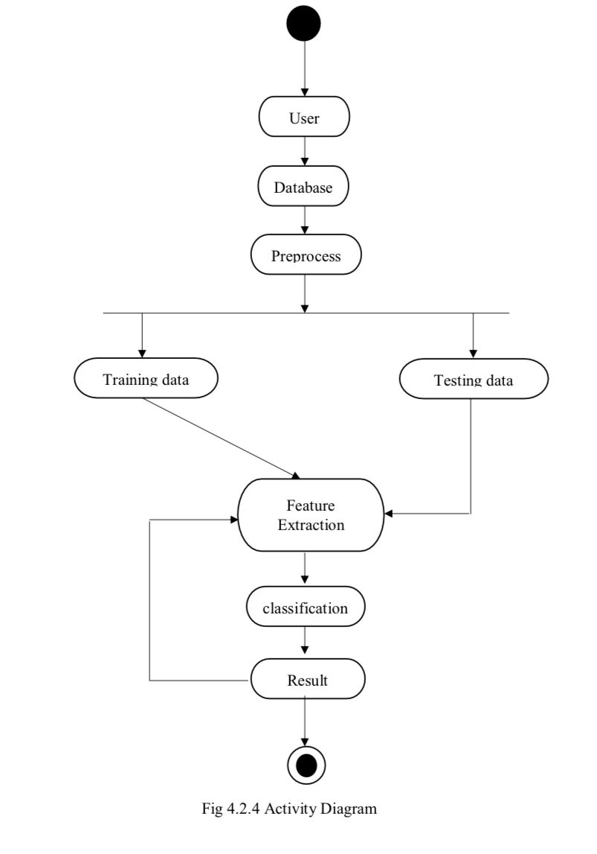

**COMPONENT DIAGRAM**

MRI Image

Image Preprocessing

1. NON DEMENTED

2. VERY MILD

3. MILD DEMENTED

4.MODERATE

Splitted into

Training

Validation

Testing

Classification Of Image Using CNN

Output Prediction